Controller 收发逻辑

Service： business logic

Domain： 数据结构

Repository： 数据库逻辑

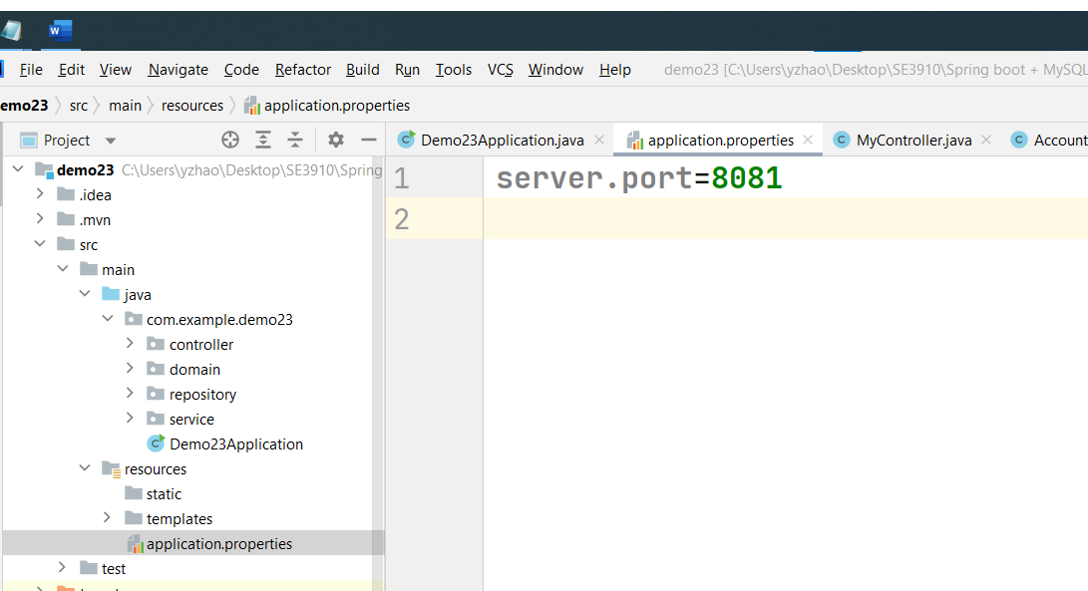

这是要和TK的reactjs的隔开。

####

我把tk的存在这里了

C:\Users\yzhao\class3910\reactjsapp\bookfrontend>



新的让我存在bookfrontend2 里面了

重新open一下



简单介绍一下这个code：



一般来说，这个index都是程序的起点。

这个id是root连在后面js上。

首先会进入这个index.js里面。

这个getElementById(‘root’)是语法，意思是这个要打开这个App



这个app在这里呢

这个app里面有一些link

path="/login"

这个path指的是



这个component指的



这玩意在这呢

这个header里面是有menu的

后面要是加个menu item就在这加

比如说，我们想加个menu item，

Student

我们就先加这么一行

不用restart，这个会自动变。

只不过点了student还是会去login

我们接下来要改造这个Login page

Rename it to be student

把里面的东西都给改成student

要去app.js里面加一下链接

回到header再给改成

就可以用了。

这回点击student会出现student page

<https://www.w3schools.com/REACT/react_usestate.asp>

Color是变量，

setColor是个函数，这个函数可以update 这个变量

这个color可以直接调用

还可以找个按钮用，setColor来改。

还可以做attribute

用这个updateColor可以做到只改一个attribute color



updateColor

  const[student, setStudent] = useState({

    first:'',

    middle:'',

    last:'',

  });

我加了一段userState

      <p> Student first name: {student.first}</p>

      <p> Student middle name: {student.middle}</p>

      <p> Student Last name: {student.last}</p>

在结尾也加了几个print

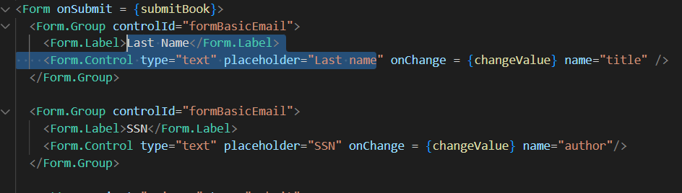

接着改了几个text

接下来看一看form的。

<https://www.w3schools.com/REACT/react_forms.asp>

这个onchange的意思是把name的text编程他输入的。

Handlesubmit的意思是点完按钮就会run这个handleSubmit

Chrome 如何打开console

这个changevalue每点一下都会往console上发一个

They the same name

这个会让默认的进入Home

我们可以把这个useEffect删掉，省着天天报错

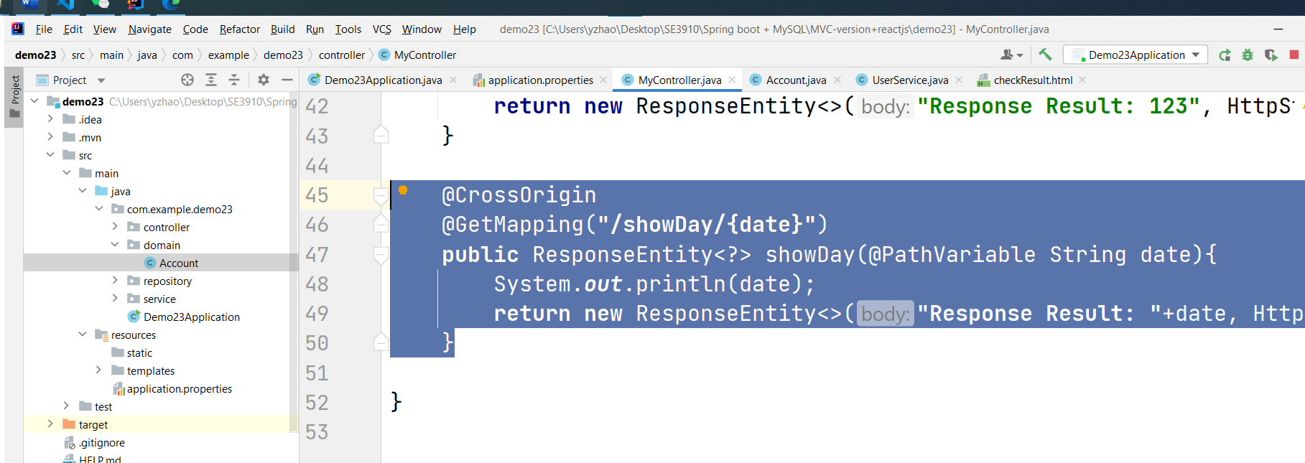

import {useState} from 'react';

import Calendar from 'react-calendar';

//import './App.css';

import 'react-calendar/dist/Calendar.css'

function Student(props) {

  const [date, setDate] = useState(new Date())

    let [showResult, setShowResult] = useState("")

    const submitDay =()=>{

        console.log("day " + date.toDateString())

        fetch('http://localhost:8081/showDay/'+ date.toDateString(),{

            method:'GET',

        })

            .then(res=> {

                    if (res.ok) {

                        res.text().then(text => {

                            console.log(text);

                            setShowResult(text);

                        });

                    }

                }

            )

    }

    return (

        <div className="app">

            <h1 className="header">React Calendar</h1>

            <div className="calendar-container">

                <Calendar onChange={setDate} value={date} onClickDay={() => submitDay()}/>

            </div>

            <div className="text-center">

                Selected date: {date.toDateString()}

                Result date: {showResult}

            </div>

        </div>

    )

}

export default Student;

Calender

import {useState} from 'react';

import Calendar from 'react-calendar';

//import './App.css';

import ReactDOM from "react-dom/client";

import 'react-calendar/dist/Calendar.css'

function App(props) {

    const [date, setDate] = useState(new Date())

    let [showResult, setShowResult] = useState("")

    const submitDay =()=>{

        console.log("day " + date.toDateString())

        fetch('http://localhost:8080/showDay/'+ date.toDateString(),{

            method:'GET',

        })

            .then(res=> {

                    if (res.ok) {

                        res.text().then(text => {

                            console.log(text);

                            setShowResult(text);

                        });

                    }

                }

            )

    }

    return (

        <div className="app">

            <h1 className="header">React Calendar</h1>

            <div className="calendar-container">

                <Calendar onChange={setDate} value={date} onClickDay={() => submitDay()}/>

            </div>

            <div className="text-center">

                Selected date: {date.toDateString()}

                Result date: {showResult}

            </div>

        </div>

    )

}

const root = ReactDOM.createRoot(document.getElementById('root1'));

root.render(<App />);

这个是work的，体力不支。要休息休息

Student

import React, { useState } from 'react';

import { Form, Button } from 'react-bootstrap';

import { propTypes } from 'react-bootstrap/esm/Image';

function Student(props) {

  const[student, setStudent] = useState({

    firstname:'',

    lastname:'',

    ssn:'',

  });

  const[book, setBook] = useState({

    title:'',

    author:'',

  });

  const changeValue=(e)=>{

    console.log(e);

    setStudent({

     ...student, [e.target.name]:e.target.value

    });

    console.log(e.target.name + " name "  );

    console.log(e.target.value + " value " );

  }

  const submitBook =(e)=>{

    e.preventDefault();

    fetch("http://localhost:8081/student", {

      method:"PUT",

      headers:{

        "Content-Type" : "application/json"

      },

      body: JSON.stringify(student)

    })

    .then(res=>{

        console.log(1,res);

        if(res.status === 201){

          return res.json();

        }else{

          return null;

        }

      })

    .then(res=>{

      console.log(res)

      if(res!==null){

        props.history.push('/login');

      }else{

        alert('fails');

      }

    });

  }

  return (

    <div>

<Form onSubmit = {submitBook}>

  <Form.Group controlId="formBasicEmail">

    <Form.Label>Last Name</Form.Label>

    <Form.Control type="text" placeholder="Last name" onChange = {changeValue} name="last" />

  </Form.Group>

  <Form.Group controlId="formBasicEmail">

    <Form.Label>SSN</Form.Label>

    <Form.Control type="text" placeholder="SSN" onChange = {changeValue} name="ssn"/>

  </Form.Group>

  <Button variant="primary" type="submit">

    Submit

  </Button>

</Form>

      <p> Student first name: {student.firstname}</p>

      <p> Student Last name: {student.lastname}</p>

    </div>

  );

}

export default Student;

I just change student to calendar

App.js

Header.js

I created a student.js again

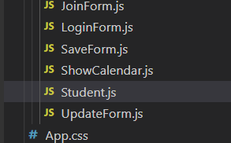

In the server:

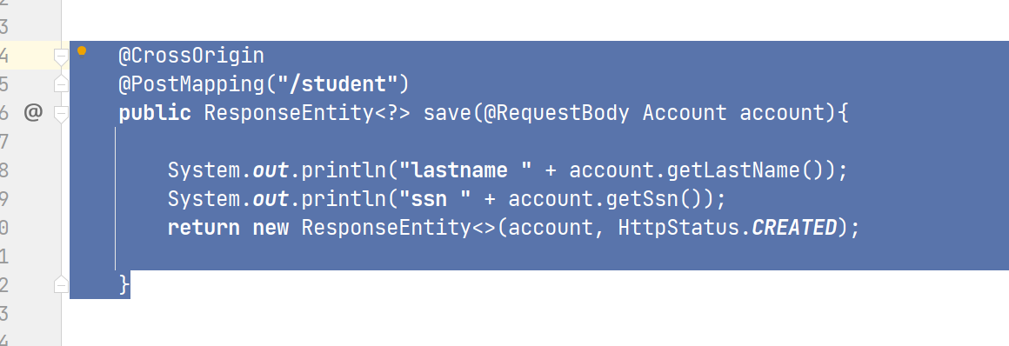

This code can receive the request from the client.

However the server needs to have the same class attributes to client

  const changeValue=(e)=>{

    console.log(e);

    setAcount({

     ...acount, [e.target.name]:e.target.value

    });

    console.log(e.target.name + " name "  );

    console.log(e.target.value + " value " );

  }

这个地方是标准语法，可以来change



调用的地方在这里，完全不用改。

@CrossOrigin  
@PostMapping(**"/student"**)  
**public** ResponseEntity<?> save(@RequestBody Account account){  
  
 System.***out***.println(**"lastname "** + account.getLastName());  
 System.***out***.println(**"ssn "** + account.getSsn());  
 account.setFirstName(**"ASD"**);  
 **return new** ResponseEntity<>(account, HttpStatus.***OK***);  
  
}

有不懂的问题可以问chatGPT

哈哈

做一个button发出去

这个地方来接

然后做一个按钮，统计一下字数。